ANTI- LEUCODERMA HERBAL PRODUCT (OINTMENT & ORAL DOSE)
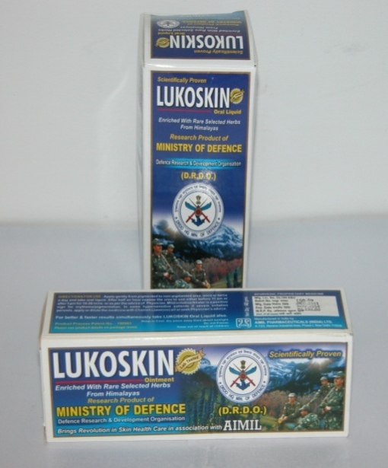
Vitiligo or alternatively leucoderma is an idiopathic acquired disorder of skin which causes pigmentry disfigurement in skin. Patients with vitiligo develop white spots in the skin with varying size and location.

There are many existing remedies viz allopathic, surgical and adjunctive therapies. But all these are either costly techniques or single component based, with very low level of efficacy and develop a number of side effects viz. blister, edema, irritation in the skin, with the result, patients discontinue the treatment.

Ointment
Taking into consideration the causes of disease and drawbacks and limitations of existing remedies, the ointment and oral dose of leucoderma which are poly component products have been formulated. In the ointment ingredients of two plants rich in furano-courmarins have been taken as skin sensitizer for initiation of erythema on the spots of vitiligo by the exposure to UVA radiation.
Oral dose
To check the emergence of new spots, the oral dose has been formulated which contains two plants having furanocoumarins as in case of ointment. The oral dose has been augmented with ash of plants rich in copper and ingredients of fifth plant rich in dihydroxy phenyl alanine, which make up the deficiency of copper and DOPA.

Toxicological studies
The toxicological studies carried out at Industrial Toxicological Research Centre (ITRC), Lucknow and DIBER Fd. Stn, Pithoragarh for acute oral toxicity, sub- acute oral toxicity, sub-chronic toxicity, Chronic toxicity, mucous membrane irritation test, skin sensitization test etc. and found safe for human application.LD₅₀ of oral dose is > 2000mg/ Kg body weight.

Clinical trials
The clinical trial of this herbal product has been carried out in different age group of patients with different ailment duration in collaboration with Civil and Ayurvedic Hospitals, Pithoragarh and Agarwal Dharmarth Hospital, Shaktinagar, New Delhi. A total of 150 patients were taken in clinical trial, out of which 100 patients were under regular treatment and placed under observation. It was evident from clinical trials results that the efficacy of this herbal product is more than 70%.
Method of Application

Ointment has to be applied topically on the white spots then expose them to sun light for ten to fifteen minutes once in a day. Oral dose has been recommended @ 2.50 ml for children and 5.00 ml for adult twice a day with 20-25 ml of water.

ANTI-ECZEMA HERBAL OINTMENT
Eczema or atopic dermatitis is an eruption of skin characterized by pin head size maculae, papules, vesicles, accompanied by intense itching in which the important features may be erythema or edema or blister formation. The etiology and clinical features of disease are guided by many predisposing factors like dryness, sweating and greasing of skin, varicose veins, family history, debility, irregular meals, constipation, fatigues, emotional shocks, anxiety, gout, renal diseases, extreme obesity, sensitivity with plant and animal products, drugs, cosmetics, chemicals, continuous fungal and bacterial infections.

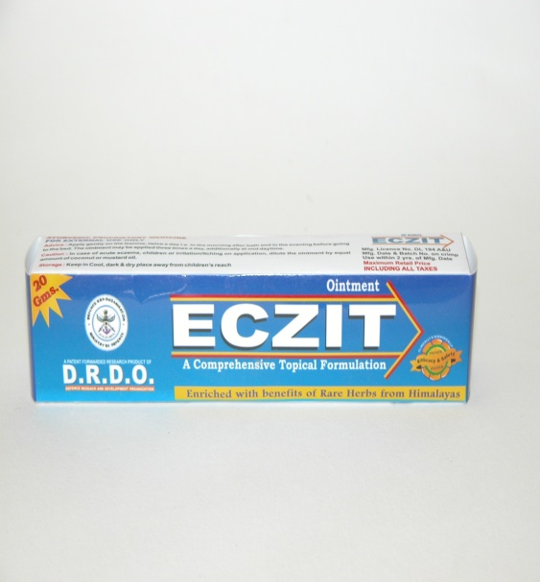

Taking into consideration the above etiological aspects, clinical features and disadvantages of modern drugs, a poly component herbal ointment which is broad spectrum effective, addresses all clinical features and contains ingredients of 10 plants has been formulated. The plants have been selected on the basis of their properties specific to the respective clinical features. To check the development of erythema, plant EC₁ with an anti-inflammatory and anti-erythematic properties has been taken. One of the ingredients of this plant is also capable of checking the secondary infection of streptococus due to its anti-bacterial properties. It also checks the fungal growth and imparts a depurative action to toxins of fungal origin. Plant EC₂ synergies the anti-erythematic and anti-inflammatory action of EC₁. Plant EC₃ having its strong antiseptic activity does not allow the microbial growth on blisters and vesicles and also helps in restoring the texture of the skin. The plant EC₄ has active ingredients that have strong alterative action on ailment. The plant EC₅ has strong antibacterial and anti-microbial properties helps in early suppuration of hard boils and also checks the skin to become lichenized. Plant EC₆ acts as germicide, anti-blister and anti-septic agent and thus helps in making the product more efficacious. The ingredients of plant EC₇ and EC₁₀ have properties to cure dryness and drying phase of eczema and scaly psoriasis stage if any. The plant EC₈ helps in curing boils and other sores and also imparts analgesic action to pain and itching. The ingredients of plant EC₉ impart odour to the ointment and also make a liniment consistency with petroleum jelly and help in softening of lichenized skin.
Toxicological studies
The toxicological studies of this herbal formulation has been carried out at Industrial Toxicological Research Centre (ITRC), Lucknow for acute oral toxicity, sub- acute oral toxicity, mucous membrane irritation test, skin sensitization test etc. and found safe for human application.

Clinical trials / Efficacy
The clinical trial of this herbal product has been carried out in different age group of patients with different ailment duration in the collaboration with the doctors of Civil and Ayurvedic Hospitals, Pithoragarh on 100 patients with different clinical features and extent of disease from mild, acute psoriasis associated eczema to lichenized skin. All the patients under observation recovered within a period of 20 to 120 days, depending on the severity and extent of disease.
Method of Application
Ointment has to apply topically on the eczematous parts twice or thrice a day.

ANTI-TOOTHACHE HERBAL SOLUTION (AMTOOTH)
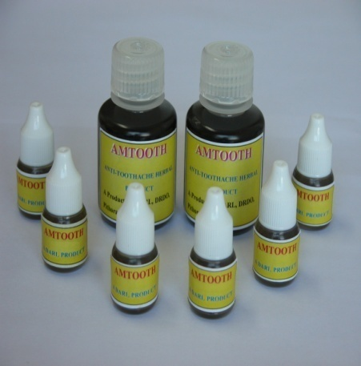
Toothache is caused by the inflammation of the nerve inside of dental pulp. Decay form cavity that extends into the pulp can cause a toothache. Infection occurs in the tooth due to bacterial infection which causes decay of tooth and excruciating pain when it spreads up to pulp and attacks root. Gradually it forms abscess in the jaw. The clinical features include infection, pain in certain tooth or over several teeth.

At first the pain may be mild, intermittent and becomes worse with hot and cold food and drinks, cold air and by the biting pressure of food. If not taken care, the tooth becomes abscessed and drains into large cavity. The packed food in the cavity gets infected due to pus from the abscess and the condition is exaggerated causing immense pain in teeth and inflammation of jaws.
Taking into consideration the clinical features of disease and drawbacks of existing remedies, the herbal solution for the cure of toothache has been formulated in which ingredients of five plants encoded as AT₁, AT₂, AT₃, AT₄, AT₅ have been taken. The active ingredients of plant AT₁ are as anti-inflammatory, analgesic and also function as local anesthetic. The plant coded as AT₂ & AT₃ have anti-odontalgic properties, AT₄, and AT5 plants have anti-inflammatory, germicidal and antiseptic properties. This way the product has been formulated as poly-component broad spectrum effective which not only checks the pain but in addition helps to recover from the cold and hot sensation of teeth and even foul smell of mouth.
Toxicological studies
The toxicological studies of this herbal formulation has been carried out at Industrial Toxicological Research Centre (ITRC), Lucknow for acute oral toxicity, sub- acute oral toxicity, mucous membrane irritation test, skin sensitization test etc. and found safe for human application.

Clinical trials / Efficacy

The clinical trial of this formulations has been carried out with the help of Dentist, Military Dental Centre, MH, Pithoragarh and Government Distt. Hospital over 300 toothache patients. 38% patients got relief within 5 minutes, 44 got relief within 10 minutes, while 13% got relieved from toothache within 15 minutes of drug application. The average effective toothache relieving time of this herbal product is 2 to 10 minutes.

Method Of Application
This herbal solution has to be applied on paining teeth with the help of a cotton swab.

